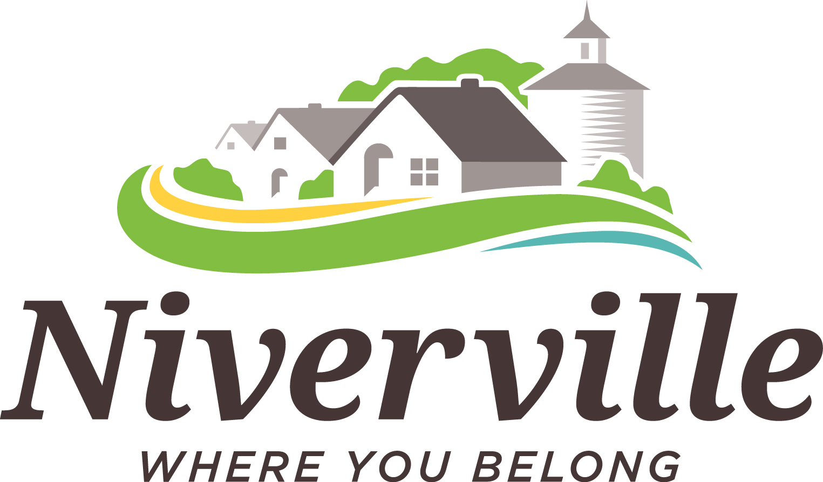

UNDER THE AUTHORITY OF THE PLANNING ACT
NOTICE OF PUBLIC HEARING

On the date and at the time and location shown below, a PUBLIC HEARING will be held to receive representations from any persons who wish to make them in respect to the following matter:

APPLICATION FOR VARIATION under the TOWN OF NIVERVILLE
ZONING BY-LAW NO. 795-18, as amended.

Meeting Niverville Community Resource & Recreation Centre
Location: 501 Centre St., Niverville, MB

Date & Time: October 1, 2024, at 9:00 a.m.

Applicant: Sunset Estates Ltd.

Location of Lots 1-30 Block 1 Plan 69034 and Lots 1-13 Block 2 Plan 69034
Proposal: Civically known as 10 to 58, 15 to 55 Gullane Street (North and South side) and 199 to 239 Kingshead Road (West side).

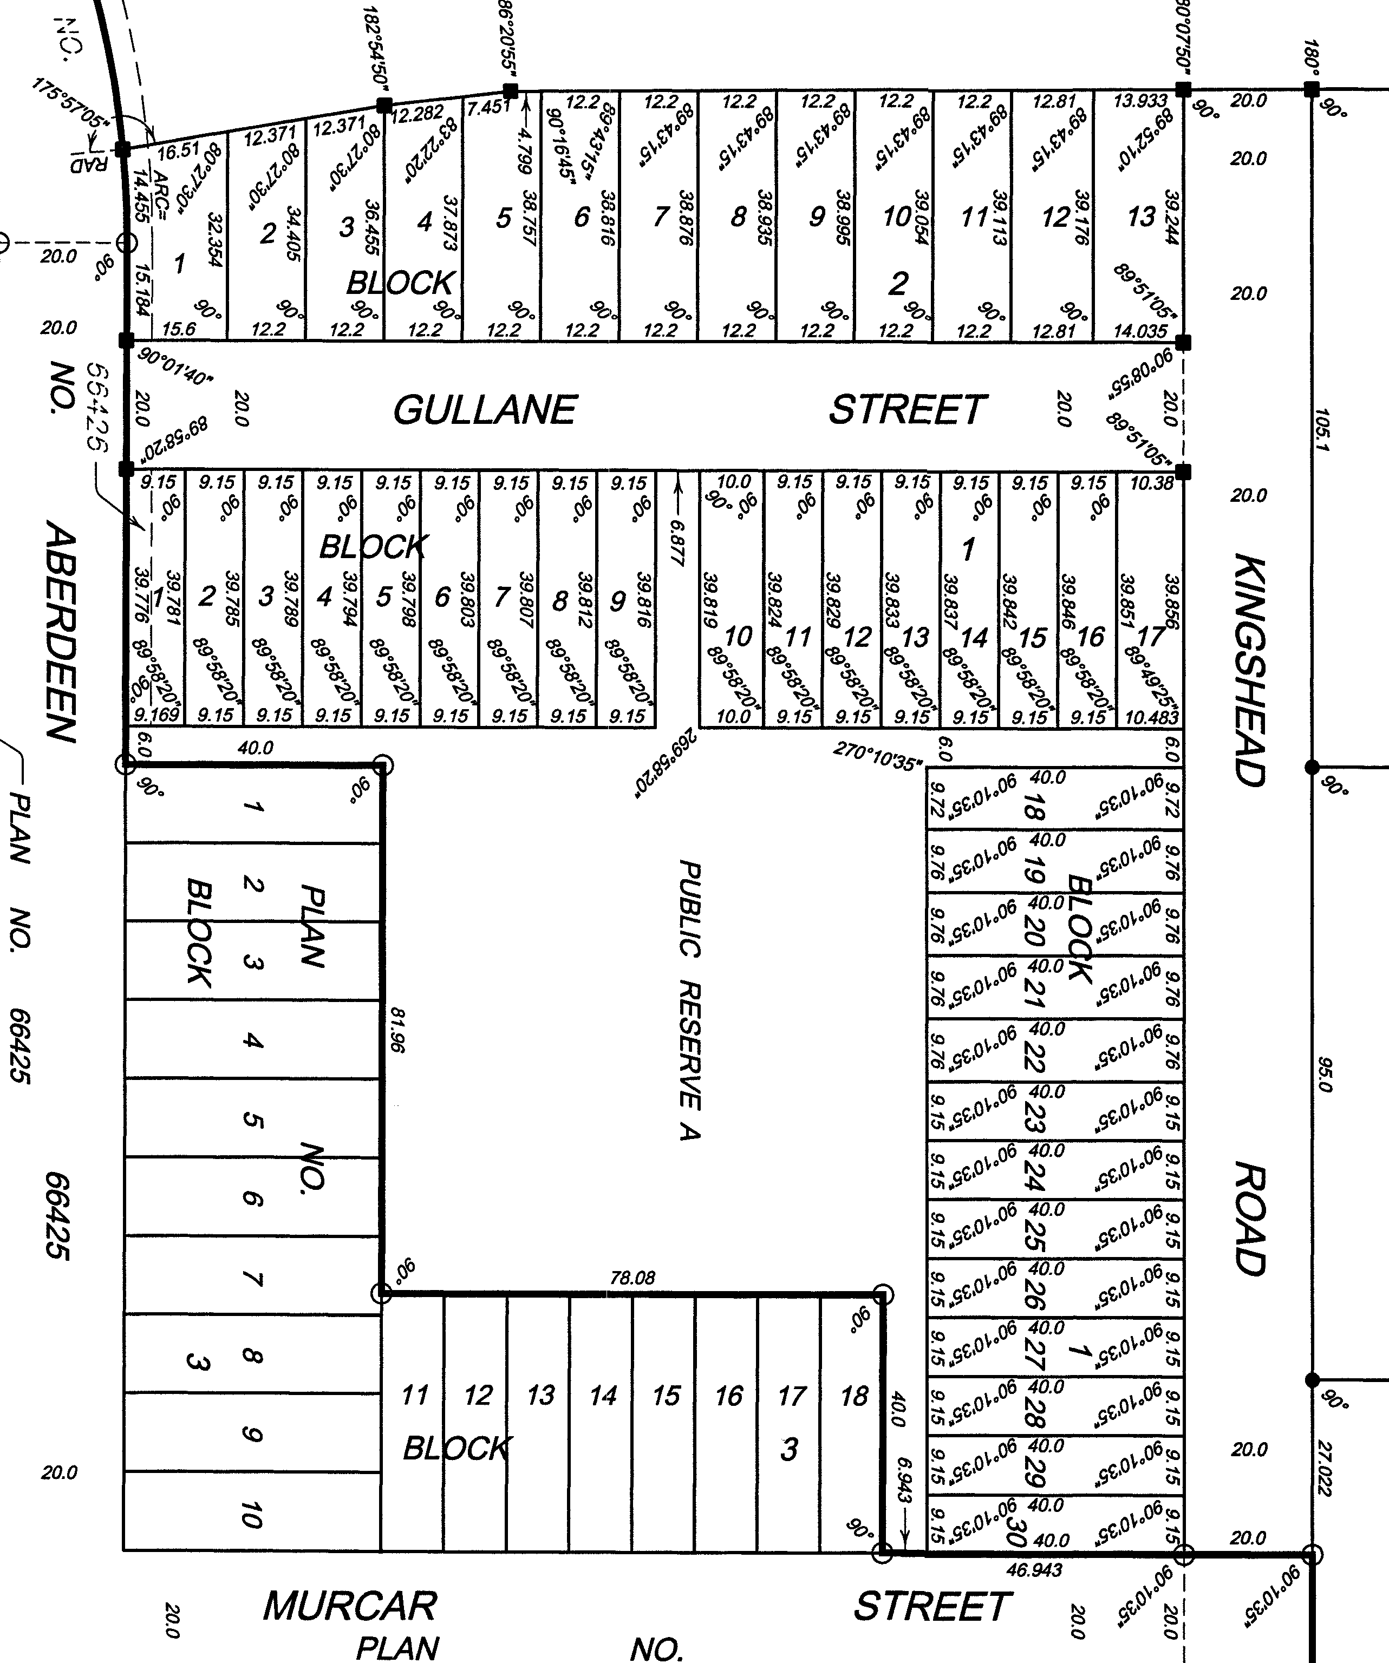
Proposal: To vary minimum side yard setbacks from
5 feet and 15 feet (if no attached garage) to
4 feet or 5 feet (attached garage) to 4 feet.

For Information Town of Niverville

Contact: Box 267, Niverville, MB R0A 1E0
Phone 204-388-4600
Email: planning@whereyoubelong.ca

A copy of the above proposal and supporting material is available to view online www.whereyoubelong.ca or may be inspected at the Town Office, 329 Bronstone Drive. Copies may be made, and extracts taken therefrom upon request. The CAO will receive objections, support or comments about the proposal by email or letter for individuals that cannot or prefer not to attend the Hearing. Please provide your communication by 12:00 p.m. on September 27, 2024, to planning@whereyoubelong.ca or drop off a letter in the drop box at 329 Bronstone Drvie. This correspondence will be presented to Council and recorded in the minutes of the Public Hearing. Anonymous comments will not be addressed.

