Licenses and Permits
Below you will find links with detailed information to many of the common permits and licenses that may be required. For clarification on whether you require a permit or license, please contact the Administration Office at 204-388-4600 or email permits@whereyoubelong.ca.

Licenses Permits

Building Permit Applications
Permits are required for any building construction, building addition, accessory buildings in excess of 108 square feet, and may be required for renovations or other structures, including but not limited to decks, sheds, and pools.
Below you will find a section for each type of permit your project may require. To apply for a building permit, please use the online permit application and upload any additional supporting documents as noted in that section. At times, additional information may be requested. If the type of project is not listed below, select “Other”. A site plan with setbacks clearly marked must be included with every permit application. A security deposit will be required for new buildings and may be required for other types of construction.

When is a Building Permit not required?
- Painting, decorating and replacement of exterior finishes.
- Replacement of doors and windows when the opening is not altered.
- Fences, however, the Zoning By-law and Design Control Guidelines specific to your area do apply. Click *here for things to consider before construction begins. [Add link to Roxie’s section on fences here]
- Sheds - if not larger than 108 sq ft., the Zoning By-law and Design Control Guidelines specific to your area do apply. A maximum of 3 accessory structures are permitted, and site coverage regulations apply.
- Deck – if less than 24” from grade on all sides, however, Zoning By-law regulations apply.

Once I receive my permit, how long do I have to commence work before my permit expires.
A development/building permit expires if the work authorized by the permit is not commenced within twelve (12) months from the date of issuance of the permit, or within any extensions granted in writing by the Designated Officer.
A permit may be revoked or suspended if a permit:
- Construction is not started within a period of twelve months from the date of issuing the permit;
- Construction is discontinued for a period of one year;
- There is a violation of any condition under which the permit was issued;
- Any alterations or deviations from the deposited plans and specifications without authority.

Residential
New Residential Home (Single Unit or Multi-Unit)
Fill out the Building Permit Application and upload the site plan, approved by the developer if applicable, engineer stamped building plans, approved by the developer if applicable and stamped by an engineer licenced in Manitoba. If a deck will be completed at the same time as the rest of the home, upload the Deck Construction Checklist as well. For multi-unit building requiring a Part 3 Permit, see “Other” section.
Building Permit Application [form]
Site Plan Example – Residential [form]
Deck Construction Checklist [form]

Deck
Deck Construction
A permit is required to construct a deck that is higher than 24” above the ground. Fill out the Building Permit Application and upload the site plan and Deck Construction Checklist. If the proposed deck will have multiple levels, an engineer stamped building plan, stamped by an engineer licenced in Manitoba is required.
Building Permit Application [form]
Deck Construction Checklist [form]
Site Plan Example – Deck, Pool [form]

Sheds
Shed Construction or Placement
A permit may be required to construct your shed. Before you begin construction, be sure to email the Town office at permits@whereyoubelong.ca to see if a permit is required and for the requirements for building a shed on your property.
Things to Consider Before Construction Begins:
- Permits are required for sheds with an area of 108 sq. ft. or greater.
- Requirements from the Town of Niverville Zoning Bylaw 795-18 as amended – including the maximum number of accessory buildings allowed on your property.
- Zone Specific guidelines for your property
- Design Control Guidelines
- Any easements or drainage concerns for your property
If access over Town property is required for the transportation or construction of the shed a separate agreement and deposit is required. Please contact permits@whereyoubelong.ca a minimum of five business days to schedule the pre-inspections prior to the date requested to access Town Property.
Building Permit Application [form]
Detached Accessory Form [form]
Site Plan Example – Detached Accessory Building [form]

Basement Finish
Basement Finish or Renovation
A permit is required to finish the basement of a new home or to renovate the basement of an existing home if the renovation will include plumbing, electrical, and adding or moving walls. A permit is not required for cosmetic changes only such as painting and flooring. Fill out the Building Permit Application and upload a basement plan including the area to be finished or renovated.
Building Permit Application [form]

POOL, HOT TUB OR OTHER WATER FEATURES
For those residents or property owners who are considering putting in a pool, hot tub or other water feature, please note that a permit may be required. Please email permits@whereyoubelong.ca for more information.
Building Permit Application [form]
Site Plan Example – Deck, Pool [form]
Access Over Town Property
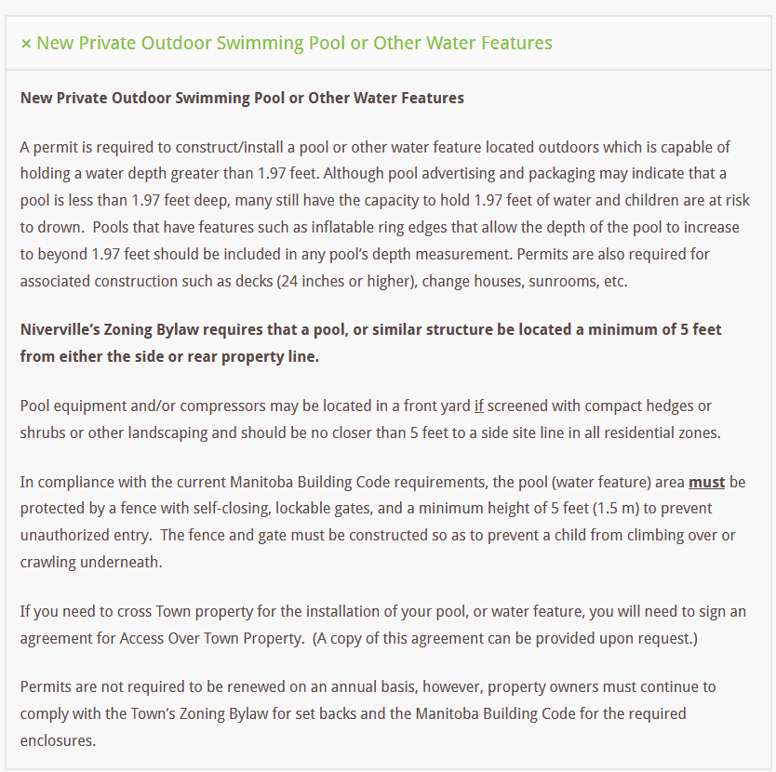
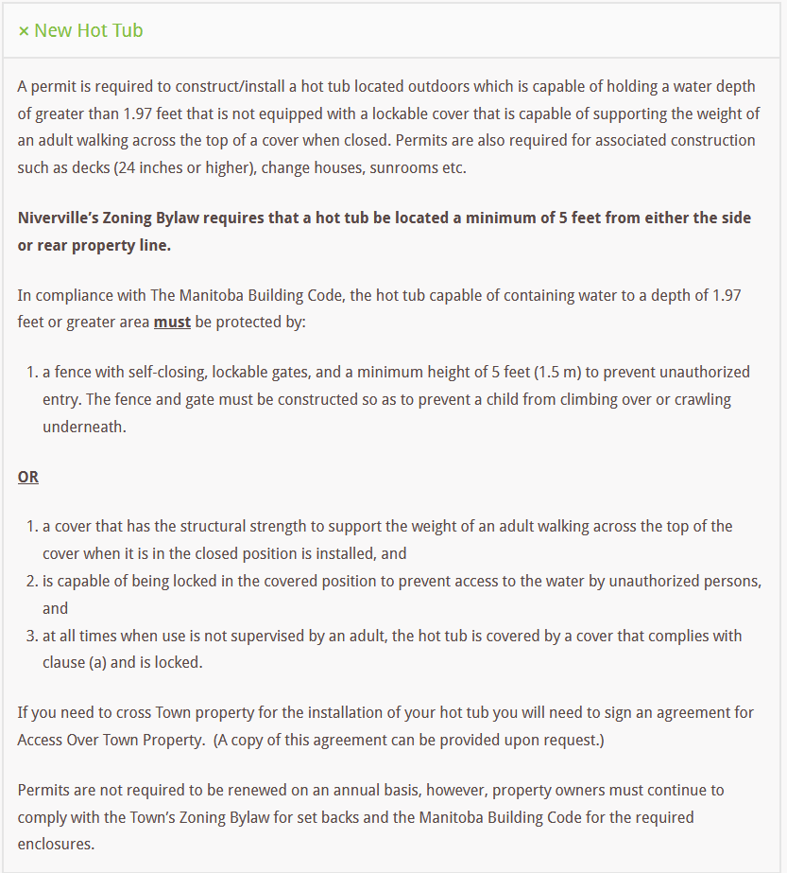
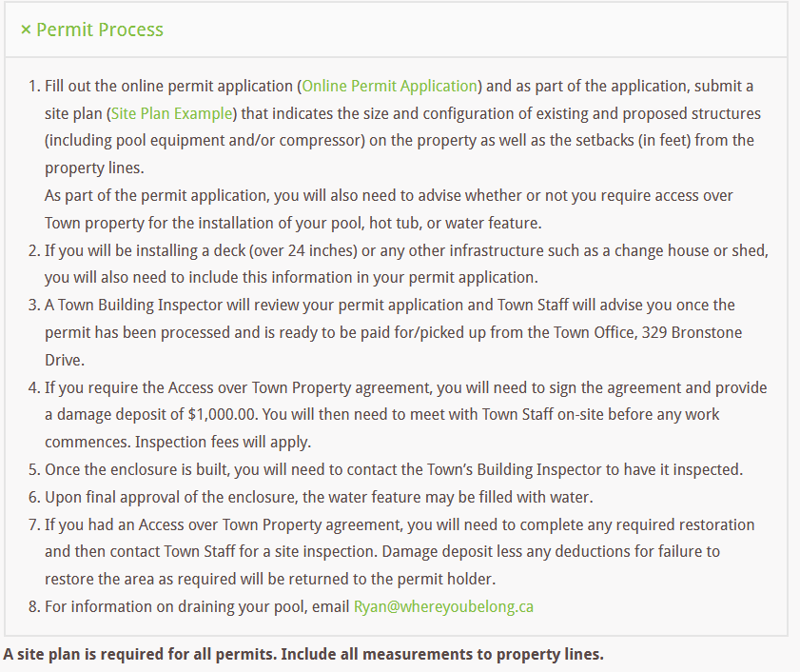

Other – Additions, Commercial, Industrial, Development Permit (Part 3)
For all other construction or renovation projects, please complete the Building Permit Application Form and upload your site plan and building plans. Please contact permits@whereyoubelong.ca if you require more information.
Building Permit Application [form]
Site Plan Example – Residential [form]
Site Plan Example – Commercial/Industrial [form]

*Roxie’s section on Fences
Fences
For residents or property owners who are considering building a fence on your property, there is important information to review before you begin construction. Please contact the Town office by emailing permits@whereyoubelong.ca for the requirements for putting a fence on your property.
Permits are not required for building a fence. However, note the following things to consider before construction begins:
- Design Control Guidelines
- Requirements from the Town of Niverville Zoning Bylaw 795-18, as amended
- Zone Specific guidelines for your property
- Any easements located on your property
- Fencing requirements for pools
- Click Before You Dig

Permits

- Building & Development Permits
- Mobile Food Service Permit
- Temporary For-Profit Permit
- Open-Air Fire Permit (link to F/D)
- Low Hazard Fireworks Display Permit (link to F/D)
- High Hazard Fireworks Display Permit (link to F/D)
- Dangerous Quantities of Fireworks Storage and Distribution Permit (link to F/D)

Licenses
- Business License
- Pet License
- Hobby Breeders License
- Lottery License

Business License
In most cases, if your homebased business generates any traffic to your home in a resident zone, an approved Conditional Use application and an annual business license at a cost of $100 per year is required. See the Conditional Use section for more information regarding this process.
A Business License is not required in a Commercial Corridor, Commercial Main Street, Industrial General or Industrial Mixed-Use zones.
Please email permits@whereyoubelong.ca for more information regarding business licenses.

Pet License
Use information and forms on website (click on title to get to it)

Hobby Breeders License
Use information and forms on website (click on title to get to it)

Lottery License
The Town may only issue a lottery license to a registered charitable or religious organization for a raffle with total prizes not exceeding $3000. If you are a registered charitable organization, proof of registration is required. Please email reception@whereyoubelong.ca to apply.
For all other liquor, gaming or cannabis inquires or licenses, please visit the Liquor, Gaming & Cannabis Authority of Manitoba (LGCA) website at https://lgcamb.ca/gaming/municipalities/.

